Implement Client Server communication model using TCP

Steps involved how to Implement Client Server communication model using TCP below in the following order-
Program 1: Write a client program to enter the number and server program to calculate the square, square root of the entered number using TCP Communication
Step1 – Write a client program.
Step2 – Write a server program.
Step3 – Program output.
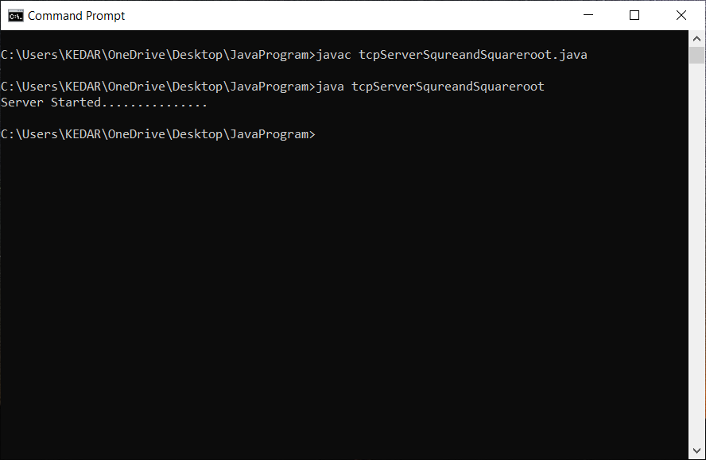
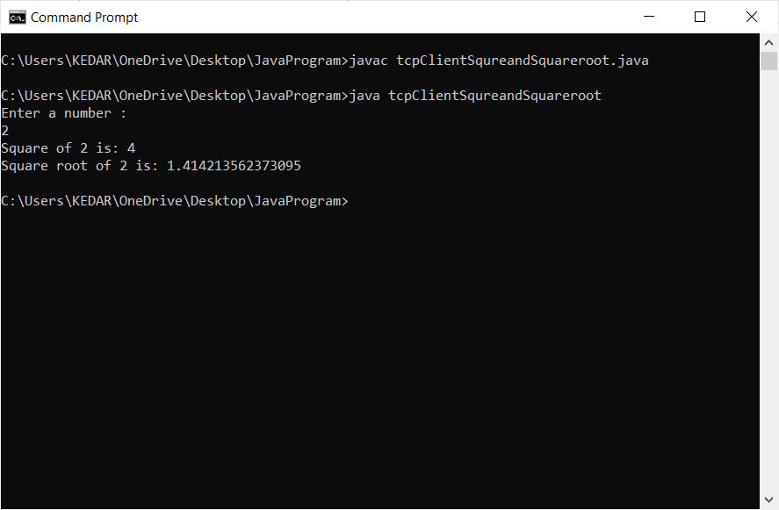

Program 2: Write a client program to enter the number and server program to calculate the cube and cube root of the entered number using TCP Communication.
Step1 – Write a client program.
Step2 – Write a server program.
Step3 – Program output.
